Clinical and Genetic Characteristics of Autosomal Recessive Polycystic Kidney Disease in Oman
Intisar Al Alawi^{1,2}, Elisa Molinari¹, Issa Al Salmi³, Fatma Al Rahbi³, Adhra Al Mawali⁴, and John A. Sayer^{1,5,6}

Supplementary Material

Supplementary Figures

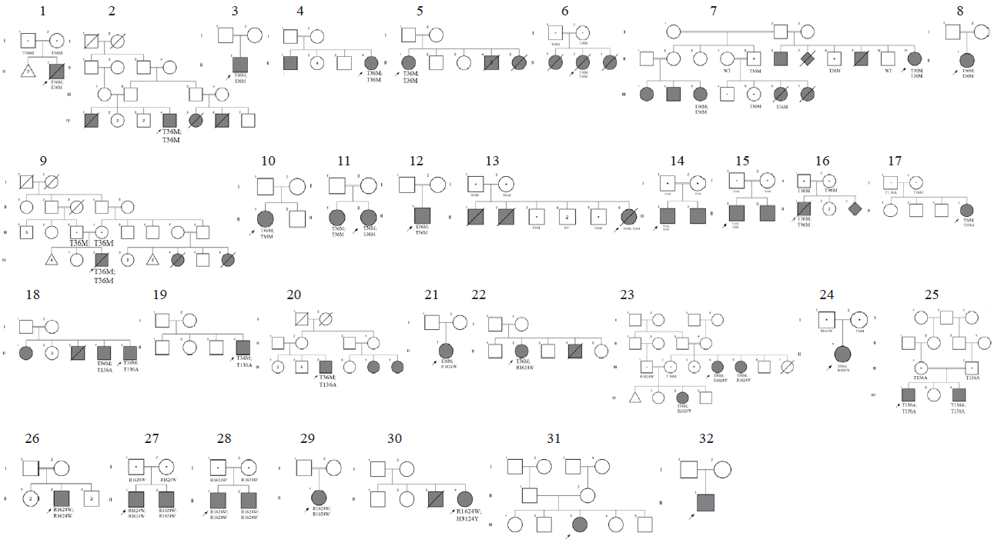
Figure S1: Pedigrees of the 33 analysed families.
Squares represent males, circles represent females. Filled symbols indicate the affected status. Double-horizontal bars illustrate parental consanguinity. Genetically solved families are 1-30. Unsolved families are 31 and 32.

Figure S2. Representation of the missense variants of the PKHD1 gene detected in ARPKD patients in relation to the gene exon structure and protein domains.
A. Chromatograms of the identified mutations in the PKHD1 gene. Heterozygous sequence variants are arrowed with the nucleotide changes indicated (reference sequence NM_138694.4)
B. Predicted protein domains of fibrocystin, with its large extracellular domain, single transmembrane domain, and short cystoplasmic tail.
C. Simplified structure of the PKHD1 transcript (longest open reading frame) (NM_138694.4) consisting of 67 exons that encode for a 4074 amino acid. Mutations are identified by red arrows.

Supplementary Tables

Table S1. Disease categories and genes selected for targeted NGS panel for cystic kidney disease.
Diseases | Gene
Autosomal dominant polycystic kidney disease (ADPKD) | PKD1, PKD2
Autosomal recessive polycystic kidney disease (ARPKD) | PKHD1
Autosomal dominant tubulo interstitial kidney disease (ADTKD) | HNF1B, REN, UMOD
Nephronophthisis (NPHP) | NPHP1, INVS, NPHP3, NPHP4, GLIS2, NEK8, TMEM67, TTC21B, WDR19, ZNF423, CEP164, ANKS6, CEP83, DCDC2, SDCCAG8 & CEP290
Medullary cystic kidney disease | UMOD, MUC1
Meckel-Gruber syndrome (MKS) | MKS1, TMEM67, CEP260, NPHP3 & RPGRIP1L
Bardet-Biedl syndrome (BBS) | BBS1, BBS2, ARL6, BBS4, BBS5, MKKS, BBS7, TTC8, BBS9, BBS10, TRIM32, BBS12, MKS1, CEP290, WDPCP, SDCCAG8, LZTFL1, BBIP1, IFT27
Autosomal dominant Polycystic liver disease (ADPLD) | PRKCSH, SEC63
Joubert syndrome (JBTS) | AHI1, NPHP1, CEP290, TMEM67, RPGRIP1L & TTC21B
Renal cysts and diabetes syndrome | HNF1B
Renal dysplasia, cystic susceptibility | BICC1

Table S2. Primers used for PCR amplification and sequencing of PKHD1 gene.
Primer Name | Gene - Exon | Sequence 5'--> 3'
PKHD1_3F | PKHD1 Exon 3 | CTGAGGCAGGTTAAATATTGCTT
PKHD1_3R | PKHD1 Exon 3 | GTCTGTTCGTCTCCCTTCAGG
PKHD1_6F | PKHD1 Exon 6 | GTGCCTCCTGTGTTTGTGAA
PKHD1_6R | PKHD1 Exon 6 | TCCAGTCTCCAACATCAACTCA
PKHD1_32AF | PKHD1 Exon 32 | AACACATGCCCTACCTTCCA
PKHD1_32AR | PKHD1 Exon 32 | AACATCACAGTTCAGGTTCCC
PKHD1_32BF | PKHD1 Exon 32 | GAAGTAACCTCTCCAACTCAGTC
PKHD1_32BR | PKHD1 Exon 32 | CCACAAATACCATCGGCTCAT
PKHD1_32CF | PKHD1 Exon 32 | TCTCTGACCACTGTGCTGAT
PKHD1_32CR | PKHD1 Exon 32 | TGAAACACTTGGGGCATAATGT
PKHD1_32DF | PKHD1 Exon 32 | TGATTAGGGGTCAGAGGTTAGC
PKHD1_32DR | PKHD1 Exon 32 | CCACTGCAAAGGTTAAGATGTCA
PKHD1_32EF | PKHD1 Exon 32 | AGGTAGATGGACTTTGGTATCACA
PKHD1_32ER | PKHD1 Exon 32 | TTTCCAGAAGTGAAAGGAGCTAC
PKHD1_58AF | PKHD1 Exon 58 | TCAGCCTTTTGTGGGGAAGA
PKHD1_58AR | PKHD1 Exon 58 | TGAAAGCCAAGAAGCCAGAG
PKHD1_58BF | PKHD1 Exon 58 | GCCTTCATCTCTATAAGGAAAGTGG
PKHD1_58BR | PKHD1 Exon 58 | TGCATGGATGTATGAAATGGCA

Table S3. Different PKHD1 founder mutations associated with different ethnicities.
Origin | Nucleotide change | aa change | Exon | Mutation Type | References
Finnish | c.1486C>T | p.R496* | 16 | Nonsense | Bergmann et al., 2003
Finnish | c.10412T>G | p.V3471G | 61 | Missense | Bergmann et al., 2003
French | c.7350+653A>G | p.G2451fs*18 | IVS46 | Intronic/Pseudo exon activation | Michel-Calemard et al., 2009
Ashkenazi | c.3761_3762delCCinsG | p.A1254Gfs*49 | 32 | Frameshift/Indel or Duplication | Quint et al., 2016
Afrikaner | c.1880 T>A | p.M627K | 20 | Missense | Lambie et al., 2015

